Expt1 celsius to Fahrenheit/kelvin conversion

2/12/2021

S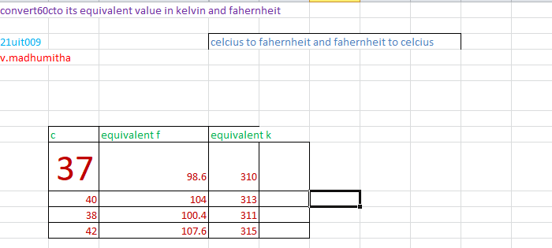

EXPT 2

